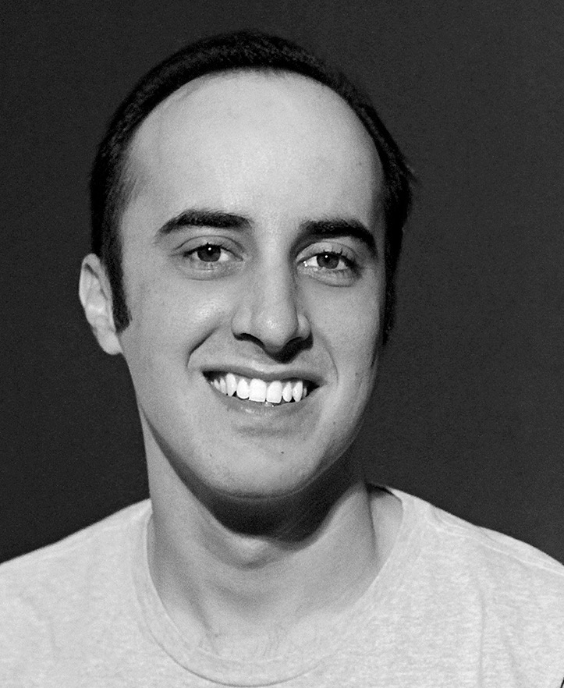

Diogo Carvalho | Short Biography

Diogo Carvalho, born in São Paulo, Brazil, is a composer, scholar, performer, and professor with experience in electroacoustic, concert, popular, jazz, and Brazilian music. He is currently a doctoral composition student at the University of Florida.
Carvalho stands out with his ample knowledge and musicality. In "Concerto for Guitar and Orchestra" (2011), the composer explores Brazilian musical gestures in classical form. In the guitar+tape piece "Reveal" (2016), Carvalho merges live guitar sonorities with pre-recorded guitar sounds processed by the computer, in an organized sonic deconstruction of the instrument. "Collage" (2017), for String Quartet, was written after the composer’s own experimentations with form, using timbre and idiomaticity as musical subjects.
As a scholar, Carvalho embraces the relationship between art and research. His studies on the compositional processes of Debussy and Ravel were linked to his transcriptions of the pieces for solo guitar, recorded in the CD "Impressionism – Acoustic Guitar Solo" (praised as “highly recommended” by Classical Guitar Magazine).
Carvalho serves the international composers community as the Director of the Composers Forum at the Vienna Summer Music Festival and the Artistic Director for the São Paulo Contemporary Composers Festival.

